|  |  |
| --- | --- |
| ENEMLOS NEWSLETTER Issue 2/2023 | |
| project monitoring | |  | | --- | | Porto | | **April, May, June 2023** | |
| The Executive Agency for Education, Audiovisual Arts and Culture (EACEA), within its competences, carried out **monitoring of the implementation** of the ENEMLOS project |
| In this issue: | |
|  |  |
|  | |

## First certificates for work at the Law Clinic



## ***Students visited Notary Chamber of Montenegro***



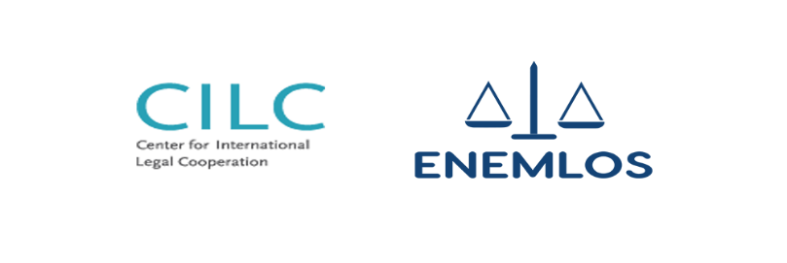**Delegation of Regent University visited Faculty of Law**

*First certificates for work at clinics*